# Call Azure function from flow using API Key

We have an Azure function to send emails. We are calling this function from Power Automate flow to send notification emails. Send email function in Azure is created to be used/ re used by all systems for sending emails in one specific format.

## Azure function API key

**Step 1:** Open your Function App in Azure portal and go to **API keys** section. Copy the value of API key from there. Here we are using _master for admin access but you can also create **new host key.**

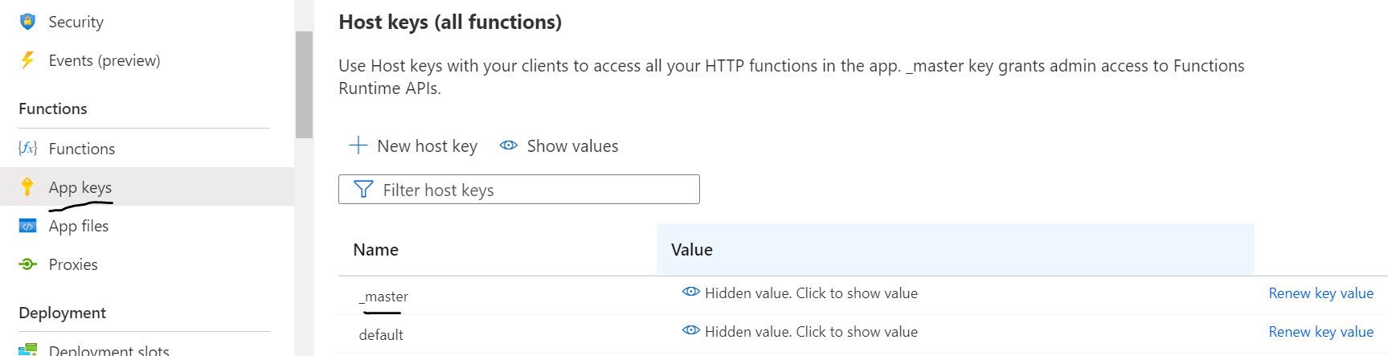

**Step 2:** In you flow use HTTP action. HTTP actions enable users to interact with APIs and send web requests that perform various operations, such as uploading and downloading data and files. Ref: <https://docs.microsoft.com/en-us/power-automate/desktop-flows/actions-reference/web>

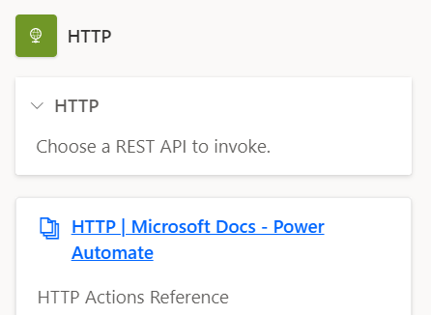

**Step 3:** Pass the API key you copied from Azure as query string with URI of Azure function. Format: FunctionAPIUrl?**code=APIKey**

